ZRAD Z-Wave Reference Application Design

Whitepaper by Eric Ryherd (aka [DrZWave](https://drzwave.blog/)) November 2024

# Summary

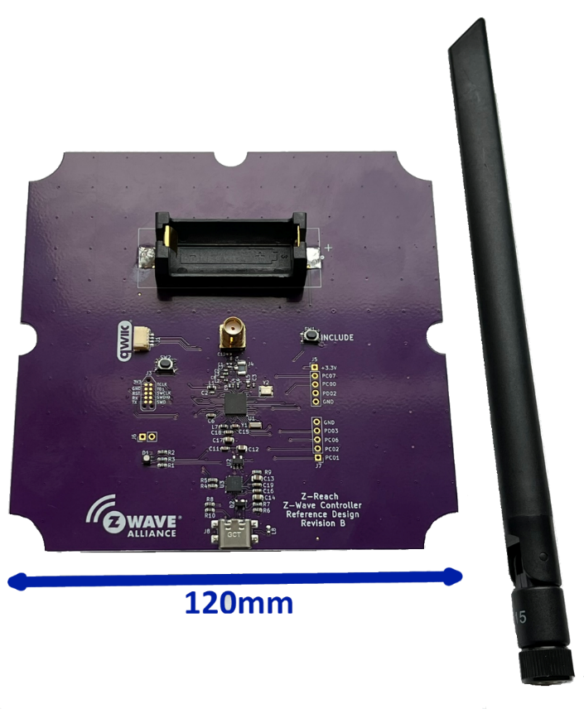The Z-Wave Alliance Z-Wave Reference Application Design (ZRAD) has proven Z-Wave Long Range easily achieves 2 miles of RF range with 100kbps data rates and fully encrypted and secure data. ZRAD is an ideal platform for Z-Wave developers to prototype new Z-Wave products or as a starting point to begin development. The best-in-class RF range is achieved with careful attention to antenna design and RF design principles.

This whitepaper includes details of real-world trials using the low-cost ZRAD in various environments from urban to rural to the beach. ZRAD is just the beginning, a new ZRADmini is currently in fabrication to lower the cost even more but with the same best-in-class RF Range.

# Motivation

The goal for ZRAD is to help alliance members accelerate their Z-Wave products to market by providing an easy to replicate reference design. Developers kits available from the Z-Wave silicon vendors typically have extra debug logic and other features that make it a challenge to use as a starting point for a Z-Wave product. ZRAD is specifically designed to be easy to use as a starting point for a new Z-Wave product. ZRAD makes an excellent prototype with expansion options and a few common features such as the Inclusion button, an LED and USB-C power. The reference design is available on Github and is free to use and copy. The schematics and PCB layout use the popular KiCAD CAD software which is easily imported into many other CAD systems. The other main goal for ZRAD is as a demonstrator for best-in-class RF range which has been demonstrated at over 2 miles. A complete technical reference manual with details on the motivation for specific design elements and the history of RF testing and debug are included.

# What is ZRAD?

The Z-Wave Alliance Z-Wave Reference Application Design (ZRAD) is a simple to copy, easy to modify, Open-Source *Reference* design of a Z-Wave best-in-class RF range device. ZRAD is not a product you can purchase, but anyone is welcome to manufacture and sell a product based on ZRAD. The objective is to accelerate Time-To-Market for Z-Wave products thru a simple to follow example with detailed step-by-step instructions.

See the [README.md](https://github.com/drzwave/ZRAD/blob/main/README.md) file in the GitHub repo for the latest information on building and using ZRAD.

## Features

* Public GitHub repository
  + Open-Source Repository
  + MIT License
* KiCAD schematic & PCB layout
  + Easily imported into other tools like Altium
  + Gerbers for immediate production
* EFR32ZG23 based +20dBm
  + 512K FLASH, 64K RAM
  + ARM CM33 CPU 39MHz
  + UARTs, Timers, I2C, ADC, DAC
* CP2102N USB->UART host interface
* Standard SerialAPI Firmware
* Documentation with full details for customization and replication
  + Simplicity Studio Sample App to full feature support example
  + Railtest examples for regulatory testing
  + Production and manufacturing test scripts
    - Crystal Calibration scripts
    - SmartStart QR code generation and label printing scripts
  + Antenna tuning and measurement example
  + PCB board Gerber file step-by-step guide
* Battery powered End Device option
* Target Assembled/tested kit cost less than $50@10K (not including enclosure)
* Target BOM cost under $15@10K

# ZRAD RF Range Testing and Results

ZRAD has been tested in a variety of environments from urban to rural. The most reproducible measurements are done in direct Line of Sight (LoS) between the controller and the end device. Other environments can produce widely varying results due to reflections and blockages of the RF signal by walls, vehicles, trees, and the terrain. The challenge is that here in the northeast US, there are relatively few places that have more than one mile of flat open space. Finding even one kilometer is difficult. But the ZRAD team has experimented with several locations and we’ve collected a lot of data which is recoded in the ZRAD repository in the Test/RangeTesting folder and in the ZRADTechDocs.docx file.

The first step in any RF product should be choosing a good antenna. The main constraint on the antenna is the physical size – for maximum wireless RF range, longer is generally better. ZRAD testing used the recommended antenna below for most of the testing.

## Antenna Choices:

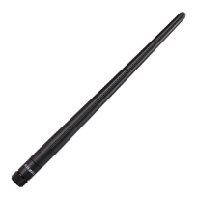The Smith Chart analysis in the ZRADTechDocs.docx[1] file shows that all antennas are NOT the same. Higher prices do not necessarily mean a better antenna. The cheapest antenna has some of the best results whereas some of the more expensive ones are not that good. Recommended SMA antennas:

* Recommended antenna is the same one often shipped with the Silabs DevKit
  + [TI.92.2113](https://www.taoglas.com/datasheets/TI.92.2113.pdf) - [$6.29](https://www.digikey.com/en/products/detail/taoglas-limited/TI-92-2113/11197416?s=N4IgTCBcDaICoEkB0BOMSwEZMGYAEIAugL5A) @1k – +1.21dBi – 198mm – 915MHz
  + [**TI.85.2113**](https://www.digikey.com/en/products/detail/taoglas-limited/TI-85-2113/11197203) is the 868 version
  + Reasonable cost, good response, not overly sensitive to nearby objects
  + GND plane didn’t make that much of a difference
* 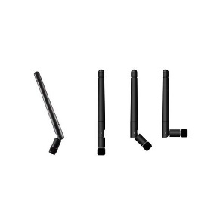Smaller low-cost alternative can be a good choice - bendable
  + [JCG402LR-2](https://www.digikey.com/en/products/detail/jc-antenna/JCG402LR-2/15814458) - $2.54@1K - +2dBi – 110mm – 915MHz
  + [**JCG402LR-1**](https://www.digikey.com/en/products/detail/jc-antenna/JCG402LR-1/15814463) is the 868 version
  + Without the GND plane has VSWR of 1.1 thus could make PCB smaller
* 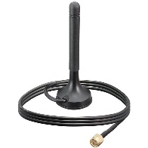Alternative option is the antenna with a cable and magnetic mount
  + [ANT-8/9-MMG1-SMA-1](https://mm.digikey.com/Volume0/opasdata/d220001/medias/docus/6146/ANT-89-MMG1-SMA-1.pdf) – $5.66@1K - +2dBi – 82mm – both 915&868
  + Could significantly reduce the size of the PCB since the GND plane isn’t needed
    - Lower cost PCB and Lower cost enclosure

Once the antenna is chosen, RF Range testing at various sites in the northeast were completed. In each test, both the controller and the end device (ED) are ZRADs unless otherwise mentioned. The ED is running a customized version of the Silabs Switch On Off sample application. In later testing, the Geographic Location Command Class V2 is used with a GPS receiver to exactly track each data point of connection. The ED is joined to the controller using SmartStart and Authenticated Security S2. The ED is then polled using 100kbps encrypted frames. Only frames that are 100% error-free can be decrypted ensuring a reliable connection. Z-Wave demonstrated the ability to resync and re-establish secure communication at the margins of the RF range in every trial. This is a high bar for the RF range, many other tests by other protocols set the cutoff point at the furthest point any data gets thru. Z-Wave ensures 100% error-free communication at the reported range.

## Great Bay NH – 2+miles RF Range Ocean - April

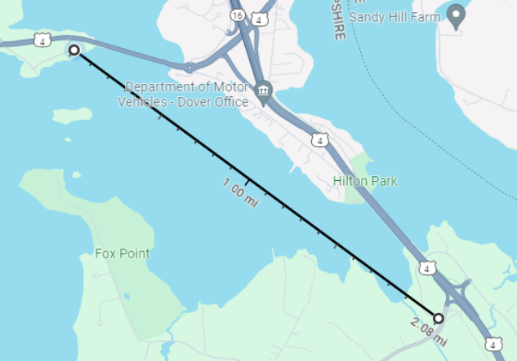Initial testing was done at various locations with 1km of LoS but it was immediately apparent that 1km isn’t far enough as ZRAD in ZWLR mode easily reaches well beyond 1km. Searching for longer open areas, the Great Bay in NH has 2 bridges and a park right at the shore with an unobstructed view of over 2 miles. ZRAD again easily reached over 2 miles and again was passing thru trees at the far end of the cove. The challenge with this location is that there are not many intermediate points that are LoS as the road between the bridges has many trees and homes and is not along the shoreline.

## Austin TX – 1.6+ miles Urban – May Z-Wave Summit

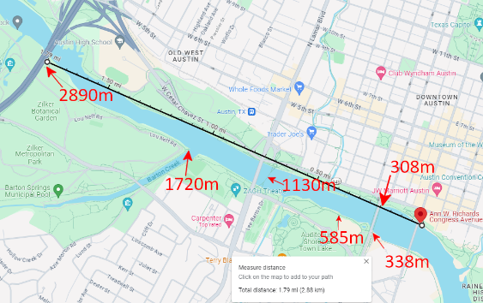The Z-Wave Unplugfest and Summit was held in downtown Austin Texas at the Silicon Labs headquarters. ZRAD and other devices were tested on the Colorado river which runs adjacent to the HQ. A linear park runs along the river but there are many trees between the path and the river itself. At the bridges there is direct LoS but these result in limited range measurements at specific distances. In an urban environment the RF noise floor is naturally higher due to all the electronics in use thus lowering the RF range. A video of the Unplugfest is available on the Alliance web site via this [LINK](https://sdomembers.z-wavealliance.org/wg/summit_presos/document/2578?downloadRevision=4012) and the presentation via this [LINK](https://sdomembers.z-wavealliance.org/wg/summit_presos/document/2511?downloadRevision=4013). The presentation on ZRAD is available via this [LINK](https://sdomembers.z-wavealliance.org/wg/summit_presos/document/2552?downloadRevision=4014).

## Boston MA – 0.66mi Urban, 0.87 suburban – August

Silicon Labs [Works With](https://www.silabs.com/about-us/events/works-with-2024) conference demonstrated the RF range of Z-Wave in a video which will be made public after the Virtual session in late November 2024. Several RF range trials were performed in different environments. In this case Silicon Labs FAE Mark Umina used a dirt bike to quickly travel across the large RF range ZRAD is capable of.

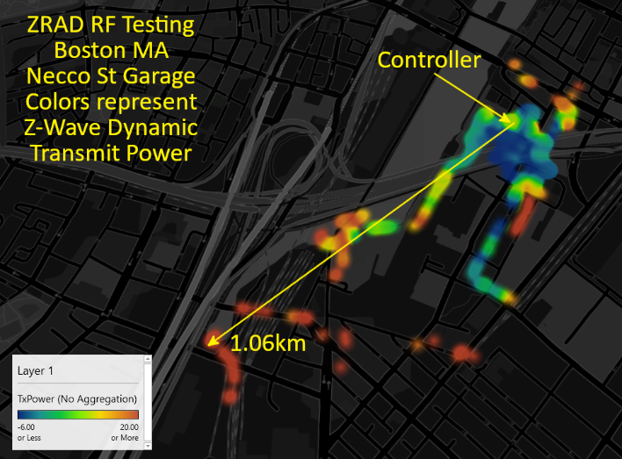This was the first trial using [Geographic Location](https://github.com/drzwave/GeographicLocationCC) Command Class V2 which uses a GPS receiver to report the exact GPS coordinates and the transmit power used at each location. Note that this is 100% secure and reliable communication at 100kpbs since corrupting even a single bit of the data means the entire message cannot be decrypted. The range is mostly limited by the LoS between the tall building in downtown Boston. The controller was located on the top floor of a parking garage which had a fairly open view across the parking lots to the southwest.

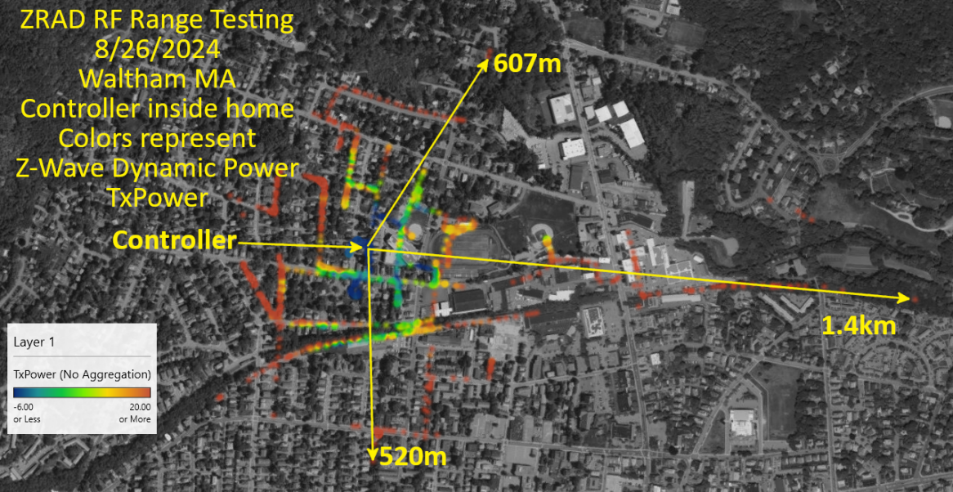The next trial was in a suburban neighborhood in Waltham MA. The controller was inside a wood-frame home and the End Device ZRAD with GeoLocCC was moved around in various neighborhoods. Note that anywhere in the house ZWLR could reach the controller with the minimum transmit power. ZRAD had to be moved to more than a block away before transmit power starts going up.

## Skydiving Pepperell MA – 2.7mi – Oct

Homeseer CTO Jonluke West is an avid skydiver and offered to take a device up on a jump to measure the RF range. You can’t get a better LoS than straight up!

The first three attempts all failed for one reason or another. A broken power connector, bugs in the GPS module (XA1110), and simply forgetting to bring the right cables seemed to make getting data from a skydive impossible. Once the team switched to the SAM-M8Q GPS module and used a 3D printed a case to securely hold the end device and the GPS receiver, the results were amazing.

A ZRAD was used as the controller located in the airport parking lot. The End Device was a Homeseer PS100 modified to connect to a SAM-M8Q GPS receiver over I2C. A customized Silicon Labs SwitchOnOff sample application reported the GPS coordinates including altitude accurately during the entire skydive. The PS100 has a PCB antenna which likely limits the RF range. The PS100 is inside a 3D printed enclosure and a fanny pack to ensure Jonlukes safety during the jump. These degrade the Z-Wave RF connection. To make up for this loss, a [Yagi](https://www.digikey.com/en/products/detail/taoglas-limited/TS-89-4113/15284364) antenna was used on the ZRAD controller and pointed toward the sky. Yagi antennas are somewhat directional but focus the RF energy in a roughly 180-degree space.

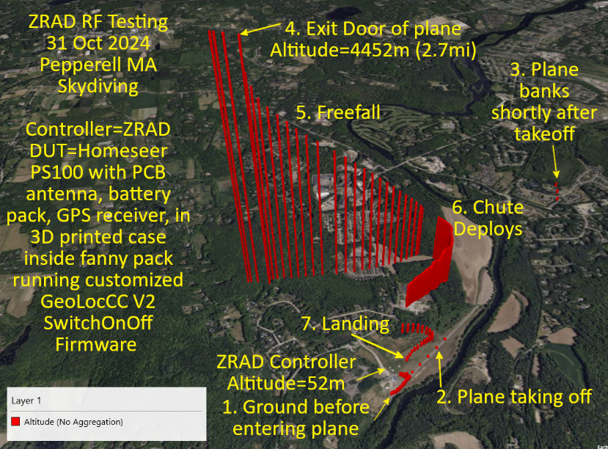The data is checked into the ZRAD/Test/RangeTesting folder. The data is plotted using Excel with the Z direction being the altitude.

The ZRAD controller is in the parking lot of the airport at an altitude of 52 meters above sea level as reported by the GPS module and confirmed using an iPhone.

1. Data begins with Jonluke walking toward and then entering the airplane
2. Data points spread out as the plane accelerates down the runway. RF connection is lost from inside the metal airplane even though Jonluke is sitting close to the large door.
3. A few more data points are captured when the plane is banking after takeoff
4. Secure connection is re-established when Jonluke is at or just outside the door of the plane but still holding on as the altitude remains the same at 4452 meters (2.7 miles). Note that Z-Wave had to negotiate the connection, exchange Nonces and then finally begin returning GPS coordinates all at the extreme edge of RF range. The TXPower is at the maximum +20dBm during this period.
5. The GPS coordinates record the rapid drop and movement of freefall
6. The chute deploys and the data points get closer together. Data is captured every three seconds. The gap in the data at this point was determined to be a bug in the GeoLocCC code which mis-interpreted certain conditions. This bug has since been fixed.
7. Jonluke lands safely and is told the data is GOOD! Finally!

A video of the skydive and more details of the equipment and results are expected to be released soon.

# How to Get a ZRAD

ZRAD is a reference design which means it’s not currently a finished product you can purchase. You can build ZRADs easily in prototype quantities. Then customize the design to make it your own!

ZRAD is a [Github](https://github.com) public repository currently hosted by DrZWave. Download the entire database from [here](https://github.com/drzwave/ZRAD). See the [Readme.md](https://github.com/drzwave/ZRAD/blob/main/README.md) file for more details and the documents in the DOCs folder.

# Future Enhancements

ZRAD isn’t the end, but just the beginning! Based on the RF testing to date, DrZWave decided the huge 4-layer ground planes of the original ZRAD are not as important to the RF range as originally thought. The large PCB is expensive and doesn’t fit in standard enclosures. 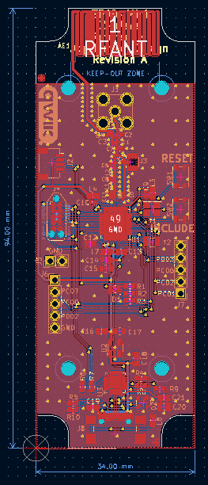This conclusion has resulted in the birth of ZRADmini! A smaller, lower cost 2-layer PCB that fits in a standard low-cost, easy to customize enclosure. ZRADmini is already in fabrication and further information will be presented at the Z-Wave Summit in 2025. The ZRADmini database is in the same ZRAD Github repo but is located under the hardware/ZRADmini folder. There is a separate ZRADmini datasheet in the docs directory and a separate Tech Document as well. ZRADmini has nearly all the same features of ZRAD but in a smaller, cheaper form. The one feature that didn’t make it was the battery holder as there just wasn’t room for it. But an optional PCB antenna was added to compare the RF range with a screw-on SMA antenna.

ZRAD will continue to evolve as it is an open-source project enabling anyone to make enhancements. Future work may include other silicon providers as well as more RF testing at various locations. One test we’ve already identified is to compare Z-Wave USB sticks with ZRADmini and the impact of putting a stick on a cable vs. plugged directly into a computer. Stay tuned!

1. The ZRADTechDocs.docx is a large document. Find the Antenna analysis by searching for “smith charts”.